Traffic and parking impact assessment

Proposed Co-Living Residential Development

32-34 Kent Street, Belmore

Prepared for: Multiform Design and Constructions Pty Ltd
N55051A (Version 1a)
March 2025
Contents
1. Introduction 3
2. Background and Existing Conditions 4
2.1. Location and Land Use 4
2.2. Road Network 6
2.3. Public Transport 9
2.4. Public Parking 10
2.5. Intersection Description 10
2.6. Existing Traffic Volumes 13
2.7. Intersection Assessment with Existing Traffic 16
2.8. Conclusion of Existing Conditions 18
3. Proposed Residential development 19
3.1. Residential development 19
3.2. Parking 19
4. Parking Requirements 20
4.1. Car Parking 20
4.2 Bicycle and Motorcycle Parking 20
5. Traffic Generation and Impact 21
4.2. Proposed Traffic Generation 21
4.3. Trip Distribution 21
4.4. Existing with Co-Living Residential Traffic 21
4.5. Traffic Impact 24
5. Conclusions 25

Introduction

Motion Traffic Engineers was commissioned by Multiform Design and Constructions Pty Ltd to undertake a traffic and parking impact assessment of a proposed co-living residential development at 32-34 Kent Street, Belmore.
The site is currently two residential houses.
This traffic report presents an assessment of the anticipated transport implications of the proposed co-living residential development, with the following considerations:
- Background and existing traffic and parking conditions of the proposed mixed-use development
- Assessment of the public transport network within the vicinity of the site
- Adequacy of car, bicycle and motorcycle parking provision
- The projected traffic generation of the proposed development
- The transport impact of the proposed development on the surrounding road network.
In the course of preparing this assessment, the subject site and its environs have been inspected, plans of the development examined, and all relevant traffic and parking data collected and analysed.

Background and Existing Conditions

Location and Land Use
The proposed residential development is located at 32-34 Kent Street, Belmore. Vehicles access and egress the site via Kent Street.
The immediate surroundings of the site are medium density residential apartment building as well as one or two storeys houses. The site is on the boundary of Belmore Town Centre..
St Wanas Coptic Orthodox Church is located on the northern side of the proposed site. Belmore Church of Christ is located to the southwest of the proposed site.
Figures 1 and 2 show the location of the proposed co-living residential development site from aerial and street map perspective respectively. Figure 2 also shows the location of the surveyed intersections in relation to the site. Figure 3 shows a photography of the site frontage taken from Kent Street.


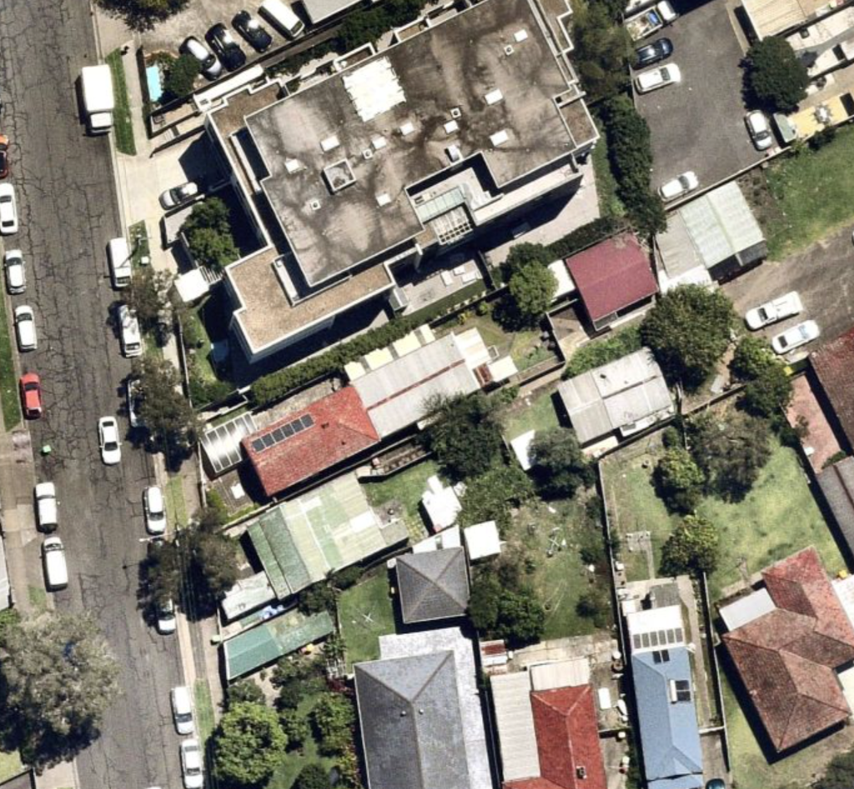
Site
Figure 1: Location of the Proposed Co-Living Residential Development on Aerial

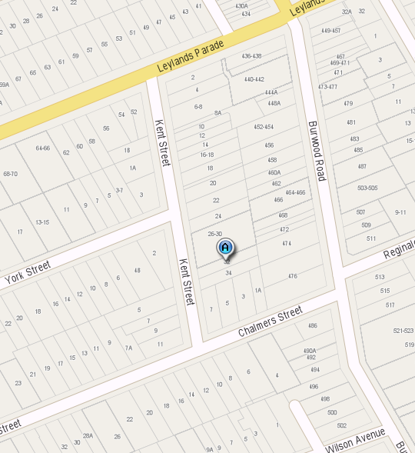
Site
Surveyed Intersections
Figure 2: Location of the Proposed Co-Living Residential Development on Aerial

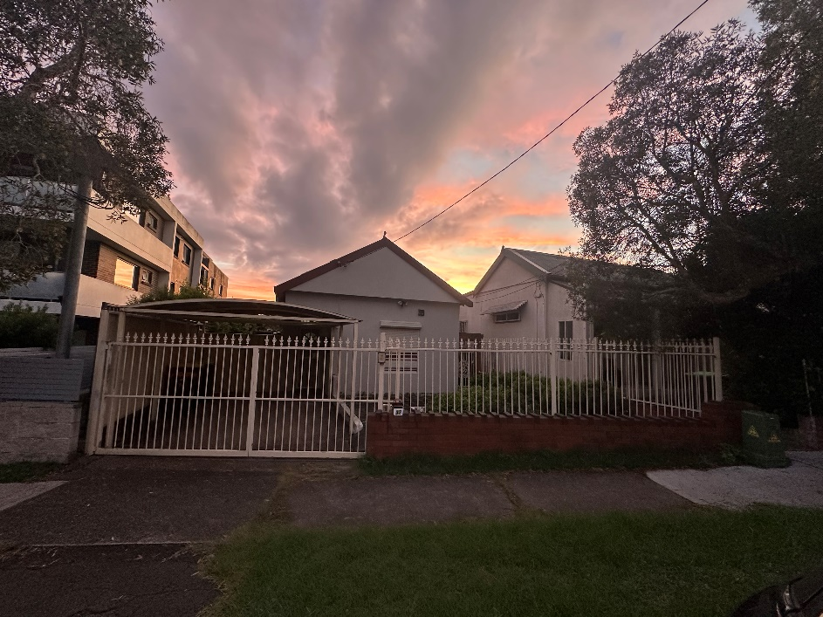
Figure 3a: Photograph of the 32 Kent Street
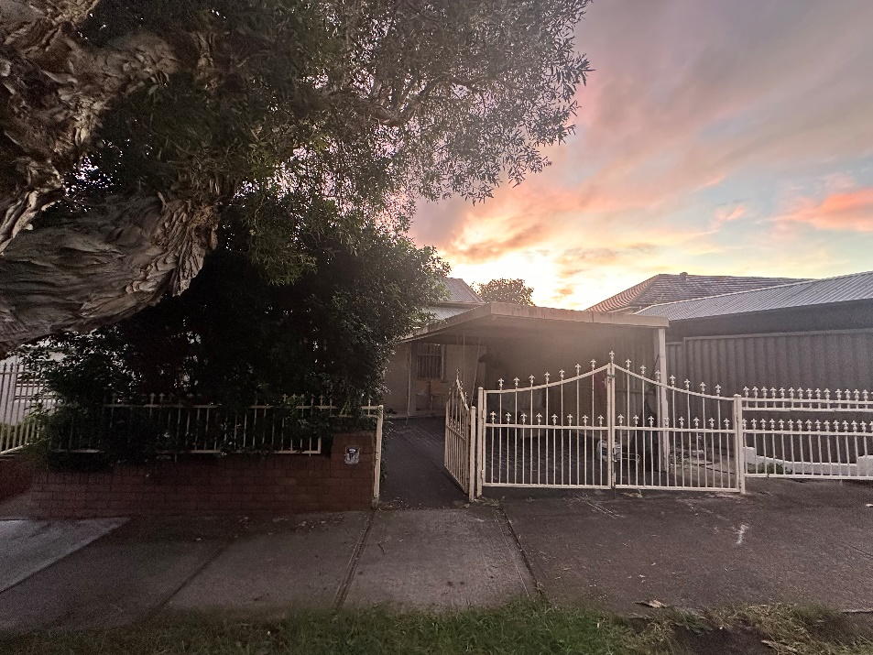
Figure 3b: Photograph of the 34 Kent Street

Road Network
This section discusses the road network adjacent to the residential development.
Kent Street is a local road with one lane of traffic in each direction. It runs north-south and serves as a key local connector, intersecting with Leylands Parade, York Street, and Chalmers Street at different points. The road has a default speed limit of 50 km/hr, with time-unrestricted on-street parking allowed on both sides. Figure 4a shows a photograph of Kent Street.
Chalmers Street is a local road with one lane of traffic in each direction. It runs east-west and connects with Kent Street. The road has a sign posted speed limit of 50 km/hr, with time-unrestricted on-street parking allowed on both sides. Figure 4b shows a photograph of Chalmers Street.
York Street is a local road with one lane of traffic in each direction. It runs west-east, connects with Kent Street, and ends at the eastern side of the area. The road has a default speed limit of 50 km/hr, with time-unrestricted on-street parking allowed on both sides. Figure 4c shows a photograph of York Street.
Leylands Parade is a collector road with one lane of traffic in each direction. It runs west to east and connects with Kent Street. The road has a sign posted speed limit of 50 km/hr, with time-unrestricted on-street parking allowed on both sides. Figure 4d shows a photograph of Leylands Parade.
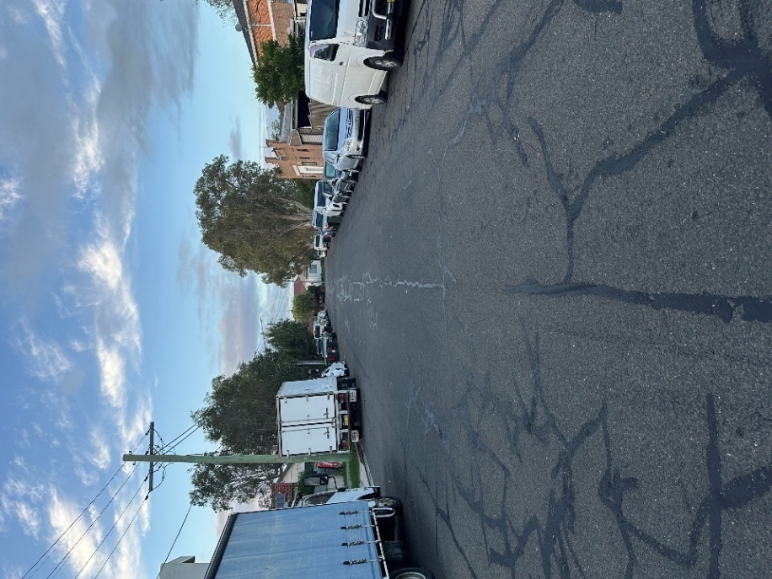
Figure 4a: Kent Street: Looking West to the Intersection
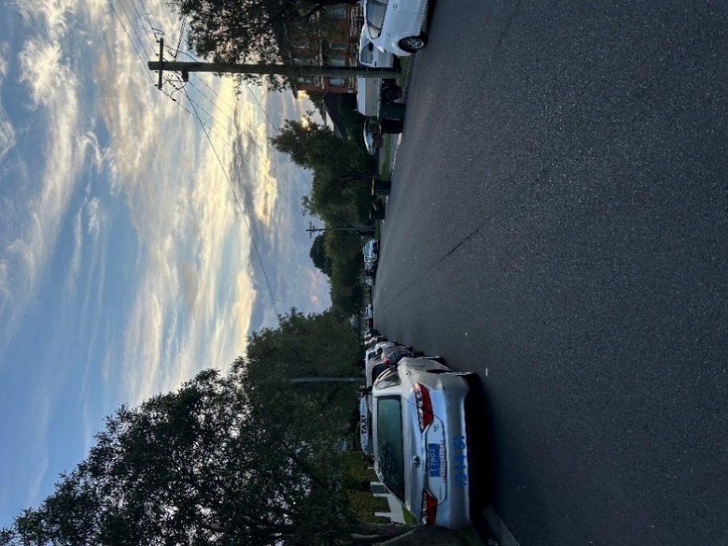
Figure 4b: Chalmers Street: Looking north from the Intersection
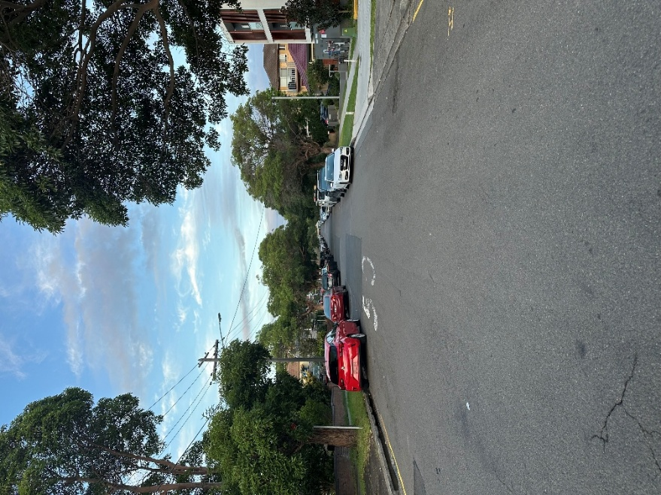
Figure 4c: York Street Looking South from the Intersection
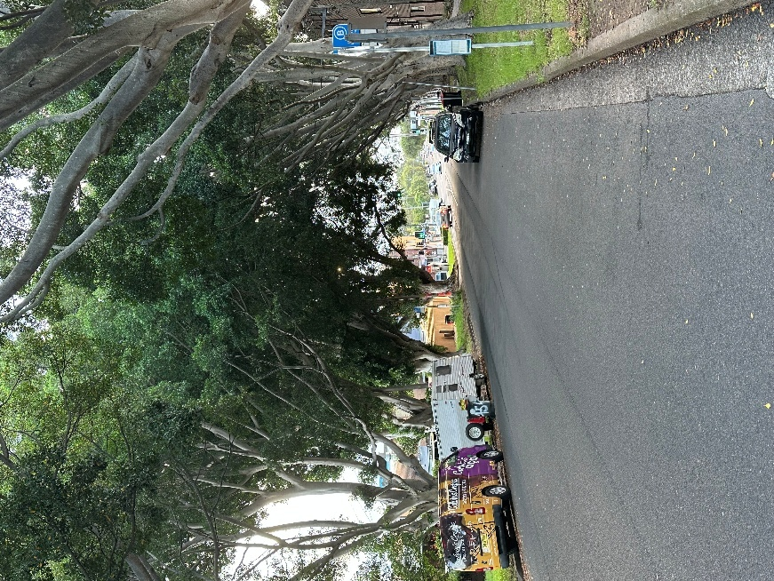
Figure 4d: Leylands Parade: Looking South from the Intersection

Public Transport
Belmore Train Station is located approximately 600 metres (walking distance) from the proposed co-living residential development. Belmore Train Station provides T3 trains run between Liverpool and the City via Regents Park and Lidcombe and Metro travel between Sydenham, the City, North Sydney and Chatswood.

A bus stop located approximately 220 metres (walking distance) from the proposed residential development provides access to bus route 415. An additional bus stop servicing route 942 is situated approximately 260 metres (walking distance) from the development.

Bus route 415 provides service from Campsie to Chiswick. Bus route 180 provides service from Collaroy Plateau to Warringah Mall. Bus route 942 provides services from Lugarno to Campsie.

Figure 5 shows the public transport services near the development.

Overall, the site has excellent access to public transport because of the proximity to the train station.

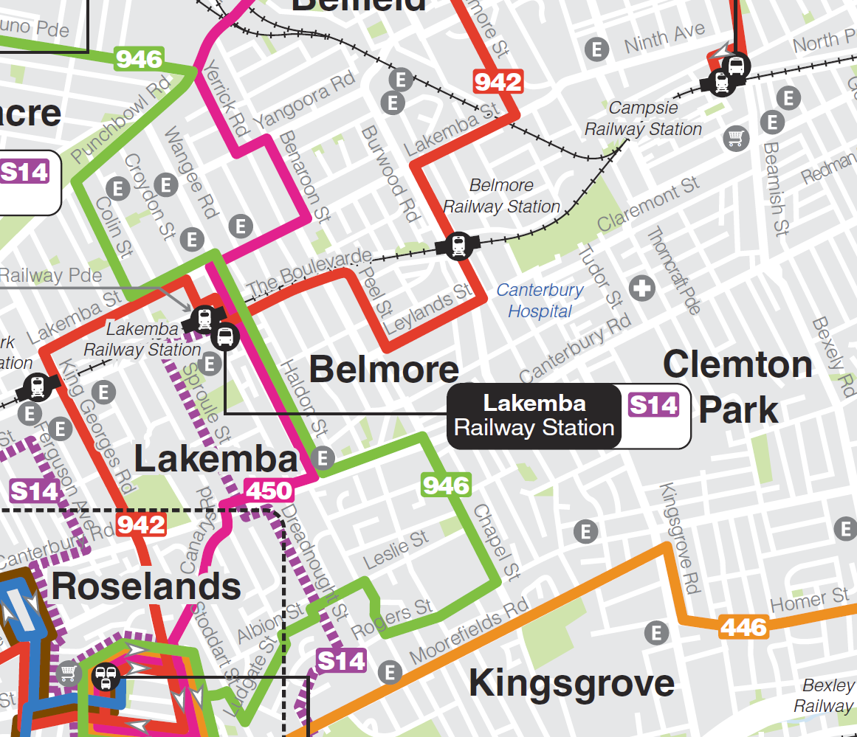
Site
Belmore Railway Station
Figure 5a: Location of the Proposed Residential Development in Relation to the Public Transport
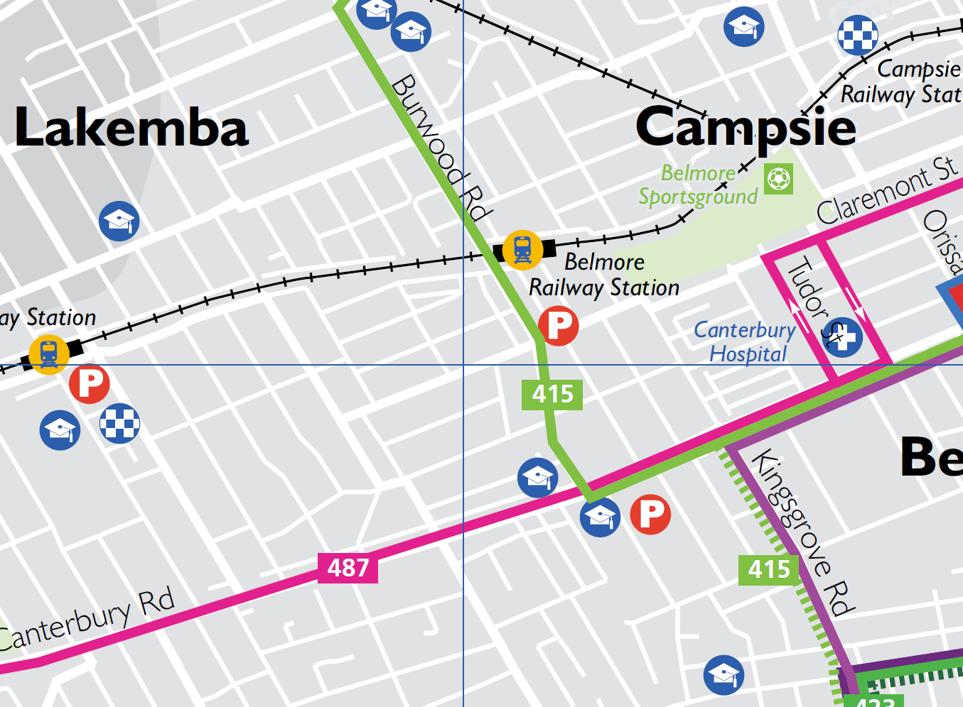
Site
Bus Route 415
Figure 5b: Location of the Proposed Residential Development in Relation to the Public Transport

Public Parking

On-street parking is provided on Kent Street and York Street. Drivers need to undertake circulate to find a vacant car space. The proposed co-living residential development does not provide visitor parking and hence visitors will need to park on-street. There are sufficient vacant car spaces for the visitors.

Intersection Description
As part of the traffic impact assessment, the performance of three nearby intersections was surveyed and assessed:
- Priority Intersection of Leylands Parade with Kent Street
- Priority Intersection of Kent Street with York Street
- Priority Intersection of Chalmers Street with Kent Street
External traffic travelling to and from the childcare centre is likely to travel through these intersections mentioned above.

The priority intersection of Leylands Parade with Kent Street is a three-leg intersection. Drivers on the Kent Street need to give way to the vehicles on the Leylands Parade. Figure 6a presents the layout of this intersection using SIDRA 9.1 (an industry standard intersection software) and Figure 6b represents the aerial view of the intersection.

The priority intersection of Kent Street with York Street is a three-leg intersection. Drivers on the York Street need to give way to the vehicles on the Kent Street. Figure 6c presents the layout of this intersection using SIDRA 9.1 and Figure 6d represents the aerial view of the intersection.

The priority intersection of Chalmers Street with Kent Street is a three-leg intersection. Drivers on the Kent Street need to give way to the vehicles on the Chalmers Street. Figure 6e presents the layout of this intersection using SIDRA 9.1 and Figure 6f represents the aerial view of the intersection.

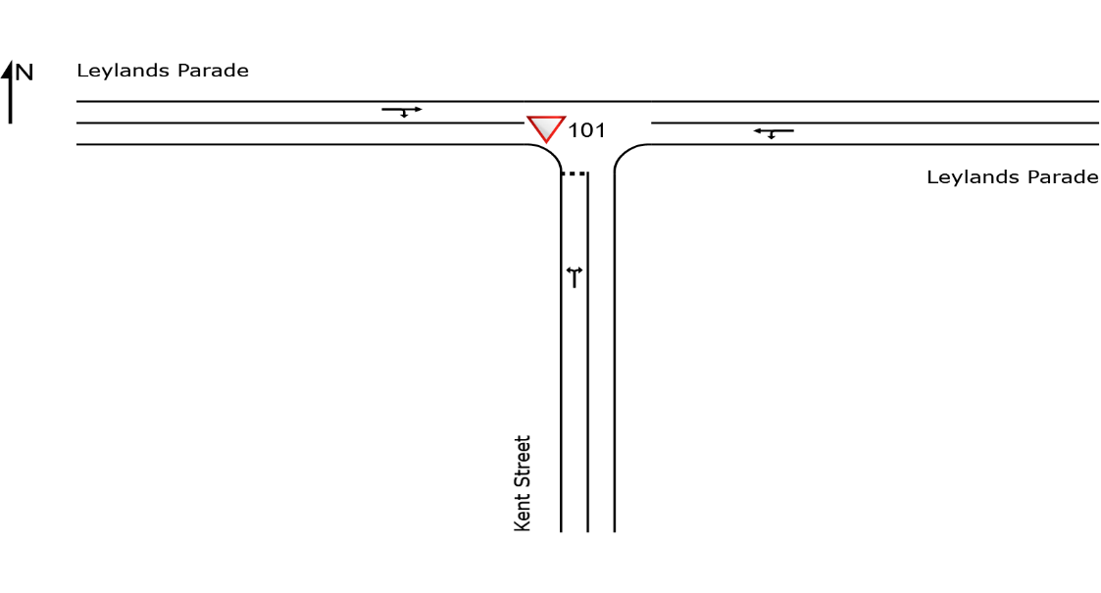

Figure 6a: Priority Intersection of Leylands Parade with Kent Street (SIDRA)
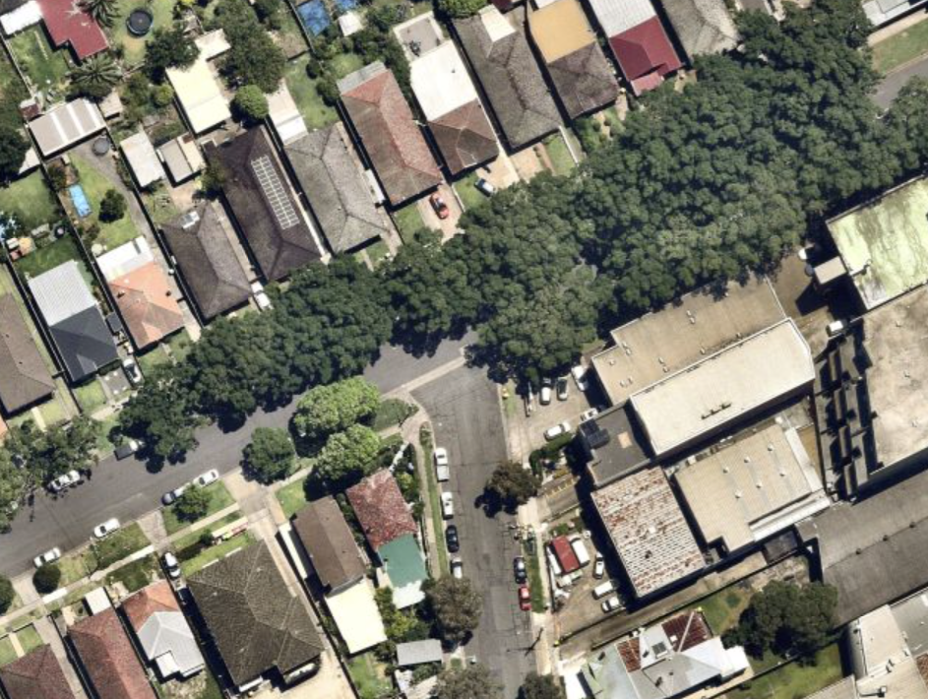
Figure 6b: Priority Intersection of Leylands Parade with Kent Street aerial view
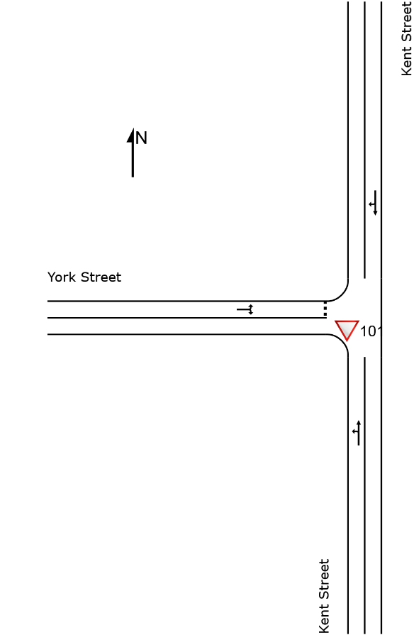
Figure 6c: Priority Intersection of Kent Street with York Street (SIDRA)

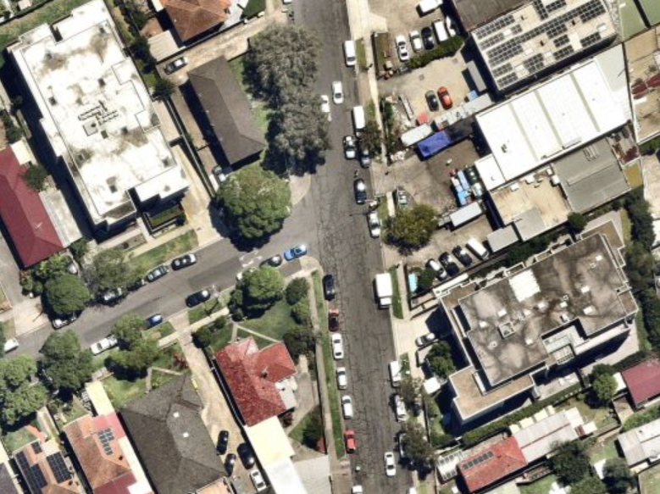
Figure 6d: Priority Intersection of Kent Street with York Street aerial view
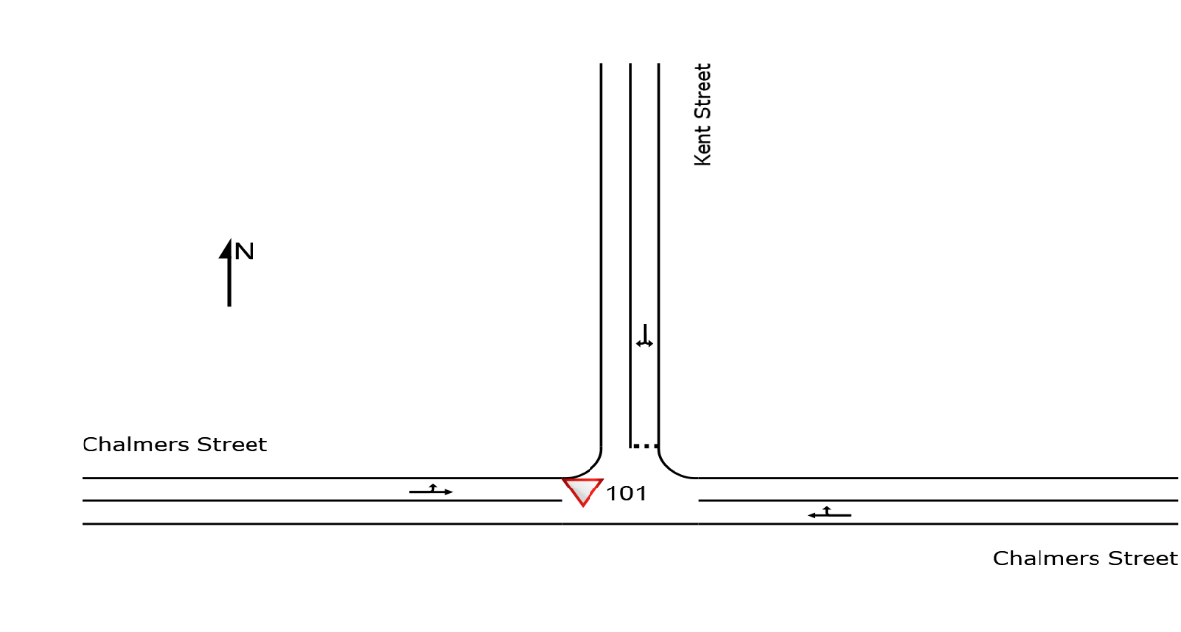
Figure 6e: Priority Intersection of Chalmers Street with Kent Street (SIDRA)

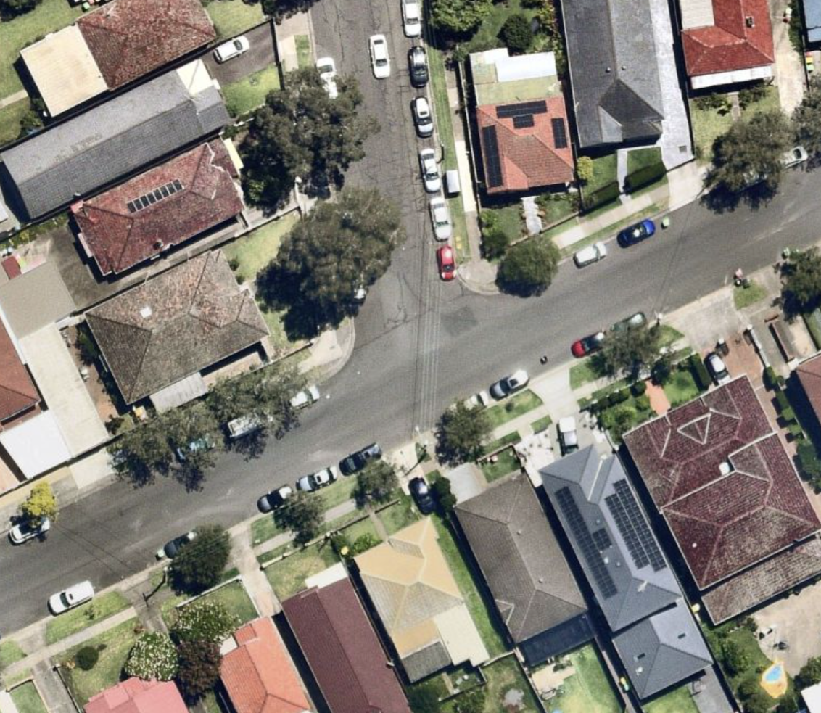
Figure 6f: Priority Intersection of Chalmers Street with Kent Street aerial view

Existing Traffic Volumes
As part of the traffic assessment, traffic counts have been undertaken at the above-mentioned intersections and the AM and PM peak hours are identified accordingly. The AM peak hour is 8am to 9am with the Pm peak is 5pm to 6pm. The traffic survey was undertaken in March 2025.
The following Figures present the traffic volumes in vehicles for the weekday peak hours.

Figure 7a: Existing Weekday Traffic Volumes AM Peak Hour

Figure 7b: Existing Weekday Traffic Volumes PM Peak Hour

Intersection Assessment with Existing Traffic
An intersection assessment has been undertaken for the:
- Priority Intersection of Leylands Parade with Kent Street
- Priority Intersection of Kent Street with York Street
- Priority Intersection of Chalmers Street with Kent Street
The existing intersection operating performance was assessed using the SIDRA software package (version 9.1) to determine the Degree of Saturation (DS), Average Delay (AVD in seconds) and Level of Service (LoS) at each intersection. The SIDRA program provides Level of Service Criteria Tables for various intersection types. The key indicator of intersection performance is Level of Service, where results are placed on a continuum from ‘A’ to ‘F’, as shown in Table 1.
LoS | Traffic Signal / Roundabout | Give Way / Stop Sign / T-Junction control
A | Good operation | Good operation
B | Good with acceptable delays and spare capacity | Acceptable delays and spare capacity
C | Satisfactory | Satisfactory, but accident study required
D | Operating near capacity | Near capacity & accident study required
E | At capacity, at signals incidents will cause excessive delays. | At capacity, requires other control mode
F | Unsatisfactory and requires additional capacity, Roundabouts require other control mode | At capacity, requires other control mode
Table 1: Intersection Level of Service
The Average Vehicle Delay (AVD) provides a measure of the operational performance of an intersection as indicated below, which relates AVD to LOS. The AVD’s should be taken as a guide only as longer delays could be tolerated in some locations (i.e. inner city conditions) and on some roads (i.e. minor side street intersecting with a major arterial route). For traffic signals, the average delay over all movements should be taken. For roundabouts and priority control intersections (sign control) the critical movement for level of service assessment should be that movement with the highest average delay.
LoS | Average Delay per Vehicles (seconds/vehicle)
A | Less than 14
B | 15 to 28
C | 29 to 42
D | 43 to 56
E | 57 to 70
F | >70
Table 2: Intersection Average Delay (AVD)
The degree of saturation (DS) is another measure of the operational performance of individual intersections. For intersections controlled by traffic signals both queue length and delay increase rapidly as DS approaches 1. It is usual to attempt to keep DS to less than 0.9. Degrees of Saturation in the order of 0.7 generally represent satisfactory intersection operation. When DS exceed 0.9 queues can be anticipated. The results of the intersection analysis are as follows

Intersection/  Performance criteria | AM Peak Hour Existing | PM Peak Hour Existing
Leylands Parade with Kent Street LoS  AVD  DS | N/A(Worst Case LoS: A)  0.7  0.125 | N/A(Worst Case LoS: A)  1.1  0.145
Kent Street with York Street  LoS  AVD  DS | N/A(Worst Case LoS: A)  1.7  0.016 | N/A(Worst Case LoS: A)  2.0  0.027
Chalmers Street with Kent Street  LoS  AVD  DS | N/A(Worst Case LoS: A)  1.4  0.050 | N/A(Worst Case LoS: A)  1.6  0.073
Table 3: Existing Intersection Performances
As presented in Table 3, all these intersections are operating at acceptable level of services. Overall, there is spare capacity to accommodate the additional traffic. The full intersection results are presented in Appendix A.

Conclusion of Existing Conditions
The proposed co-living residential development is located in an area where there are a reasonable number of vacant car spaces on a weekday along on Kent Street and York Street.

The nearby intersections perform well to accommodate additional traffic.

The site has excellent access to public transport.

Proposed Residential development

A description of the development for which approval is now sought features the following elements:
- Demolition and Construction of a Co-living residential development

Residential development
The proposed residential development will accommodate the following:
- Total of 35 rooms

Parking
Car parking is provided on basement level with vehicle access and egress via the driveway that runs off Kent Street.
- 7 car spaces (including an accessible car spaces)
- 8 bicycle racks
- 2 motorcycle spaces

A full scaled plan of the proposed residential development is provided as part of the Development Application.

Parking Requirements
  - Car Parking
The State Environmental Planning Policy (Housing) 2021 outlines the minimum parking requirements for co-living residential developments as follows:

- 0.2 parking spaces per private room in accessible area.
The site is approximately 650 meters from the Belmore Station, meeting the criteria for an "accessible area" as defined by the State Environmental Planning Policy (Housing) 2021.
Table 4 below presents the minimum car parking requirement for the proposed co-living residential development based on the car parking rates listed above.
 | Number of Dwellings | Car Parking Rate | Car Spaces Required | Car Spaces Provided
Co-Living  Residential Development | 35 | 0.2 car spaces per room | 7 | 7
 |  | Total |  | 7
Table 4: Summary of SEPP Car Parking Requirements
Therefore, there are sufficient parking availability for residents and parents. As shown in the table 4, the proposed co-living development overall complies with State Environmental Planning Policy (Housing) 2021 parking requirements.

Bicycle and Motorcycle Parking
Although neither the Canterbury Bankstown Development Control Plan nor the State Environmental Planning Policy (Housing) 2021 explicitly specify the number of bicycle and motorcycle parking spaces required, the development includes adequate provision—8 bicycle spaces and 2 motorcycle spaces—to meet anticipated demand.

5. Traffic Generation and Impact

Proposed Traffic Generation
The NSW RTA Guide to Traffic Impact Assessment 2024 have not outlines the trip generation rates for a Co-living Residential Development. However, given that the development provides seven car spaces and is located in an accessible location near a train station, it is reasonable to make assumption that the proposed site will generate seven trips in the weekday

Trip Distribution
The proposed co-living residential is a low trip generator in both AM and PM peak hours
The predicted residential trips are distributed across the road network, assuming 90 percent origin trips and 10% destination trips during the AM peak hour and vice versa for the PM peak hour.
Table5 presents the trip distribution for the proposed co-living residential development.

 | Peak Hour | Origin | Destination | Net Trips
Net Trips | AM | 6 | 1 | 7
 | PM | 1 | 6 | 7
Table 5: Trip Distribution

Existing with Co-Living Residential Traffic
The additional residential development trips are assigned onto the local traffic network. The following figures present the existing traffic volume with the residential development trips (in red for origin trips and blue for destination trips) for the weekday AM and PM peak hours.
Figure 8a: Existing Weekday Traffic Volumes with co-living residential development traffic AM Peak Hour
Figure 8b: Existing Weekday Traffic Volumes with co-living residential development traffic PM Peak Hour

Traffic Impact
This section assesses the following intersections for the existing traffic with the childcare traffic. The results of the intersection assessment are as follows:
Intersection/  Performance criteria | Performance with  Existing Traffic |  | Projected Performance with Existing and Co-Living Residential traffic
 | AM Peak Hour Existing | PM Peak Hour Existing | AM Peak Hour Projected | PM Peak Hour Projected
Leylands Parade with Kent Street  LoS  AVD  DS | N/A(Worst Case LoS: A)  0.7  0.125 | N/A(Worst Case LoS: A)  1.1  0.145 | N/A(Worst Case LoS: A)  0.7  0.125 | N/A(Worst Case LoS: A)  1.1  0.146
Kent Street with York Street  LoS  AVD  DS | N/A(Worst Case LoS: A)  1.7  0.016 | N/A(Worst Case LoS: A)  2.0  0.027 | N/A(Worst Case LoS: A)  1.7  0.018 | N/A(Worst Case LoS: A)  2.0  0.027
Chalmers Street with Kent Street  LoS  AVD  DS | N/A(Worst Case LoS: A)  1.4  0.050 | N/A(Worst Case LoS: A)  1.6  0.073 | N/A(Worst Case LoS: A)  1.5  0.050 | N/A(Worst Case LoS: A)  1.6  0.073
Table 6: Projected intersection performance with childcare traffic
As presented in Table 6 above, the additional trips generated by the proposed residential development have minimum impact on the intersection performances in AM peak hours. The LoS, AVD and DS of each intersection are not significantly affected by the addition of mixed-use development traffic.
The traffic impacts of the proposed residential development are therefore considered acceptable.
The full SIDRA results are presented in Appendix B for the future conditions with the residential development traffic.

Conclusions

This traffic impact assessment reports relates to a proposed co-living residential development at 32-34 Kent Street, Belmore. Based on the analysis and discussions presented in this report, the following conclusions are made:
- The proposed co-living residential development is in a residential area with excellent access to local public transport service and there are a reasonable number of vacant car spaces on a weekday along on Kent Street
- The nearby assessed intersections perform well with spare capacity for the existing traffic conditions
- The car parking requirements outlined in the State Environmental Planning Policy (Housing) 2021 has been used for this assessment. The proposed co-living residential development complies with State Environmental Planning Policy (Housing) 2021’s car parking requirements
- The proposed co-living residential development is expected to generate a low number of additional trips in AM peak hours.
- According to the intersection assessment, the additional trips can be accommodated in the nearby intersections without significantly affecting the performance of any turn movement, approach arm or the overall intersection. The traffic impacts of the proposed development are therefore considered acceptable.

There are no traffic engineering reasons why a development consent for the xo-living residential development in Belmore should be refused.

Appendix A
INTERSECTION ASSESSMENT FOR EXISTING TRAFFIC
Vehicle Movement Performance
Mov  ID | Turn | Mov  Class | Demand Flows |  | Arrival Flows |  | Deg.  Satn |  | Aver.  Delay | Level of  Service |  | 95% Back Of Queue |  | Prop.  Que |  | Eff.  Stop Rate | Aver.  No. of  Cycles | Aver.  Speed
 |  |  | [ Total | HV ] | [ Total | HV ] |  |  |  |  |  | [ Veh. | Dist ]
 |  |  | veh/h | % | veh/h | % | v/c |  | sec |  |  | veh | m |  |  |  |  | km/h
South: Kent Street
1 | L2 | All MCs | 9 | 0.0 | 9 | 0.0 | 0.031 |  | 5.0 | LOS A |  | 0.1 | 0.7 | 0.34 |  | 0.57 | 0.34 | 45.2
3 | R2 | All MCs | 22 | 0.0 | 22 | 0.0 | 0.031 |  | 6.1 | LOS A |  | 0.1 | 0.7 | 0.34 |  | 0.57 | 0.34 | 45.0
Approach |  |  | 32 | 0.0 | 32 | 0.0 | 0.031 |  | 5.8 | LOS A |  | 0.1 | 0.7 | 0.34 |  | 0.57 | 0.34 | 45.1
East: Leylands Parade
4 | L2 | All MCs | 7 | 0.0 | 7 | 0.0 | 0.087 |  | 4.6 | LOS A |  | 0.0 | 0.0 | 0.00 |  | 0.02 | 0.00 | 48.6
5 | T1 | All MCs | 158 | 4.0 | 158 | 4.0 | 0.087 |  | 0.0 | LOS A |  | 0.0 | 0.0 | 0.00 |  | 0.02 | 0.00 | 49.8
Approach |  |  | 165 | 3.8 | 165 | 3.8 | 0.087 |  | 0.2 | NA |  | 0.0 | 0.0 | 0.00 |  | 0.02 | 0.00 | 49.8
West: Leylands Parade
11 | T1 | All MCs | 224 | 2.8 | 224 | 2.8 | 0.125 |  | 0.0 | LOS A |  | 0.1 | 0.7 | 0.04 |  | 0.04 | 0.04 | 49.7
12 | R2 | All MCs | 13 | 0.0 | 13 | 0.0 | 0.125 |  | 5.0 | LOS A |  | 0.1 | 0.7 | 0.04 |  | 0.04 | 0.04 | 48.3
Approach |  |  | 237 | 2.7 | 237 | 2.7 | 0.125 |  | 0.3 | NA |  | 0.1 | 0.7 | 0.04 |  | 0.04 | 0.04 | 49.6
All Vehicles |  |  | 434 | 2.9 | 434 | 2.9 | 0.125 |  | 0.7 | NA |  | 0.1 | 0.7 | 0.04 |  | 0.07 | 0.04 | 49.3
Table A1: Weekday Priority Intersection of Leylands Parade with Kent Street AM Peak Hour
Vehicle Movement Performance
Mov  ID | Turn | Mov  Class | Demand Flows |  | Arrival Flows |  | Deg.  Satn |  | Aver.  Delay | Level of  Service |  | 95% Back Of Queue |  | Prop.  Que |  | Eff.  Stop Rate | Aver.  No. of  Cycles | Aver.  Speed
 |  |  | [ Total | HV ] | [ Total | HV ] |  |  |  |  |  | [ Veh. | Dist ]
 |  |  | veh/h | % | veh/h | % | v/c |  | sec |  |  | veh | m |  |  |  |  | km/h
South: Kent Street
1 | L2 | All MCs | 6 | 0.0 | 6 | 0.0 | 0.016 |  | 4.6 | LOS A |  | 0.0 | 0.0 | 0.00 |  | 0.12 | 0.00 | 48.1
2 | T1 | All MCs | 23 | 9.1 | 23 | 9.1 | 0.016 |  | 0.0 | LOS A |  | 0.0 | 0.0 | 0.00 |  | 0.12 | 0.00 | 49.3
Approach |  |  | 29 | 7.1 | 29 | 7.1 | 0.016 |  | 1.0 | NA |  | 0.0 | 0.0 | 0.00 |  | 0.12 | 0.00 | 49.0
North: Kent Street
8 | T1 | All MCs | 24 | 0.0 | 24 | 0.0 | 0.014 |  | 0.0 | LOS A |  | 0.0 | 0.1 | 0.03 |  | 0.07 | 0.03 | 49.6
9 | R2 | All MCs | 3 | 0.0 | 3 | 0.0 | 0.014 |  | 4.6 | LOS A |  | 0.0 | 0.1 | 0.03 |  | 0.07 | 0.03 | 48.1
Approach |  |  | 27 | 0.0 | 27 | 0.0 | 0.014 |  | 0.5 | NA |  | 0.0 | 0.1 | 0.03 |  | 0.07 | 0.03 | 49.4
West: York Street
10 | L2 | All MCs | 11 | 0.0 | 11 | 0.0 | 0.013 |  | 4.6 | LOS A |  | 0.0 | 0.3 | 0.09 |  | 0.51 | 0.09 | 45.8
12 | R2 | All MCs | 7 | 0.0 | 7 | 0.0 | 0.013 |  | 4.7 | LOS A |  | 0.0 | 0.3 | 0.09 |  | 0.51 | 0.09 | 45.6
Approach |  |  | 18 | 0.0 | 18 | 0.0 | 0.013 |  | 4.7 | LOS A |  | 0.0 | 0.3 | 0.09 |  | 0.51 | 0.09 | 45.7
All Vehicles |  |  | 75 | 2.8 | 75 | 2.8 | 0.016 |  | 1.7 | NA |  | 0.0 | 0.3 | 0.03 |  | 0.19 | 0.03 | 48.3
Table A2: Weekday Priority Intersection of Kent Street with York Street AM Peak Hour

Vehicle Movement Performance
Mov  ID | Turn | Mov  Class | Demand Flows |  | Arrival Flows |  | Deg.  Satn |  | Aver.  Delay | Level of  Service |  | 95% Back Of Queue |  | Prop.  Que |  | Eff.  Stop Rate | Aver.  No. of  Cycles | Aver.  Speed
 |  |  | [ Total | HV ] | [ Total | HV ] |  |  |  |  |  | [ Veh. | Dist ]
 |  |  | veh/h | % | veh/h | % | v/c |  | sec |  |  | veh | m |  |  |  |  | km/h
East: Chalmers Street
5 | T1 | All MCs | 63 | 0.0 | 63 | 0.0 | 0.045 |  | 0.1 | LOS A |  | 0.1 | 0.8 | 0.10 |  | 0.15 | 0.10 | 49.1
6 | R2 | All MCs | 18 | 11.8 | 18 | 11.8 | 0.045 |  | 5.0 | LOS A |  | 0.1 | 0.8 | 0.10 |  | 0.15 | 0.10 | 47.5
Approach |  |  | 81 | 2.6 | 81 | 2.6 | 0.045 |  | 1.2 | NA |  | 0.1 | 0.8 | 0.10 |  | 0.15 | 0.10 | 48.7
North: Kent Street
7 | L2 | All MCs | 19 | 0.0 | 19 | 0.0 | 0.023 |  | 4.8 | LOS A |  | 0.1 | 0.6 | 0.19 |  | 0.51 | 0.19 | 45.5
9 | R2 | All MCs | 11 | 10.0 | 11 | 10.0 | 0.023 |  | 5.3 | LOS A |  | 0.1 | 0.6 | 0.19 |  | 0.51 | 0.19 | 45.2
Approach |  |  | 29 | 3.6 | 29 | 3.6 | 0.023 |  | 5.0 | LOS A |  | 0.1 | 0.6 | 0.19 |  | 0.51 | 0.19 | 45.4
West: Chalmers Street
10 | L2 | All MCs | 9 | 0.0 | 9 | 0.0 | 0.050 |  | 4.6 | LOS A |  | 0.0 | 0.0 | 0.00 |  | 0.05 | 0.00 | 48.4
11 | T1 | All MCs | 85 | 3.7 | 85 | 3.7 | 0.050 |  | 0.0 | LOS A |  | 0.0 | 0.0 | 0.00 |  | 0.05 | 0.00 | 49.7
Approach |  |  | 95 | 3.3 | 95 | 3.3 | 0.050 |  | 0.5 | NA |  | 0.0 | 0.0 | 0.00 |  | 0.05 | 0.00 | 49.5
All Vehicles |  |  | 205 | 3.1 | 205 | 3.1 | 0.050 |  | 1.4 | NA |  | 0.1 | 0.8 | 0.07 |  | 0.16 | 0.07 | 48.6
Table A3: Weekday Priority Intersection of Chalmers Street with Kent Street AM Peak Hour
Vehicle Movement Performance
Mov  ID | Turn | Mov  Class | Demand Flows |  | Arrival Flows |  | Deg.  Satn |  | Aver.  Delay | Level of  Service |  | 95% Back Of Queue |  | Prop.  Que |  | Eff.  Stop Rate | Aver.  No. of  Cycles | Aver.  Speed
 |  |  | [ Total | HV ] | [ Total | HV ] |  |  |  |  |  | [ Veh. | Dist ]
 |  |  | veh/h | % | veh/h | % | v/c |  | sec |  |  | veh | m |  |  |  |  | km/h
South: Kent Street
1 | L2 | All MCs | 16 | 0.0 | 16 | 0.0 | 0.055 |  | 5.4 | LOS A |  | 0.2 | 1.3 | 0.39 |  | 0.61 | 0.39 | 45.1
3 | R2 | All MCs | 36 | 0.0 | 36 | 0.0 | 0.055 |  | 6.5 | LOS A |  | 0.2 | 1.3 | 0.39 |  | 0.61 | 0.39 | 44.9
Approach |  |  | 52 | 0.0 | 52 | 0.0 | 0.055 |  | 6.1 | LOS A |  | 0.2 | 1.3 | 0.39 |  | 0.61 | 0.39 | 44.9
East: Leylands Parade
4 | L2 | All MCs | 26 | 0.0 | 26 | 0.0 | 0.145 |  | 4.6 | LOS A |  | 0.0 | 0.0 | 0.00 |  | 0.05 | 0.00 | 48.4
5 | T1 | All MCs | 252 | 1.7 | 252 | 1.7 | 0.145 |  | 0.0 | LOS A |  | 0.0 | 0.0 | 0.00 |  | 0.05 | 0.00 | 49.6
Approach |  |  | 278 | 1.5 | 278 | 1.5 | 0.145 |  | 0.5 | NA |  | 0.0 | 0.0 | 0.00 |  | 0.05 | 0.00 | 49.5
West: Leylands Parade
11 | T1 | All MCs | 172 | 1.8 | 172 | 1.8 | 0.101 |  | 0.1 | LOS A |  | 0.1 | 0.9 | 0.08 |  | 0.10 | 0.08 | 49.5
12 | R2 | All MCs | 17 | 0.0 | 17 | 0.0 | 0.101 |  | 5.5 | LOS A |  | 0.1 | 0.9 | 0.08 |  | 0.10 | 0.08 | 48.0
Approach |  |  | 188 | 1.7 | 188 | 1.7 | 0.101 |  | 0.6 | NA |  | 0.1 | 0.9 | 0.08 |  | 0.10 | 0.08 | 49.4
All Vehicles |  |  | 518 | 1.4 | 518 | 1.4 | 0.145 |  | 1.1 | NA |  | 0.2 | 1.3 | 0.07 |  | 0.12 | 0.07 | 49.0
Table A4: Weekday Priority Intersection of Leylands Parade with Kent Street PM Peak Hour

Vehicle Movement Performance
Mov  ID | Turn | Mov  Class | Demand Flows |  | Arrival Flows |  | Deg.  Satn |  | Aver.  Delay | Level of  Service |  | 95% Back Of Queue |  | Prop.  Que |  | Eff.  Stop Rate | Aver.  No. of  Cycles | Aver.  Speed
 |  |  | [ Total | HV ] | [ Total | HV ] |  |  |  |  |  | [ Veh. | Dist ]
 |  |  | veh/h | % | veh/h | % | v/c |  | sec |  |  | veh | m |  |  |  |  | km/h
South: Kent Street
1 | L2 | All MCs | 12 | 0.0 | 12 | 0.0 | 0.027 |  | 4.6 | LOS A |  | 0.0 | 0.0 | 0.00 |  | 0.12 | 0.00 | 48.1
2 | T1 | All MCs | 39 | 5.4 | 39 | 5.4 | 0.027 |  | 0.0 | LOS A |  | 0.0 | 0.0 | 0.00 |  | 0.12 | 0.00 | 49.3
Approach |  |  | 51 | 4.2 | 51 | 4.2 | 0.027 |  | 1.1 | NA |  | 0.0 | 0.0 | 0.00 |  | 0.12 | 0.00 | 49.0
North: Kent Street
8 | T1 | All MCs | 28 | 0.0 | 28 | 0.0 | 0.024 |  | 0.1 | LOS A |  | 0.1 | 0.6 | 0.10 |  | 0.21 | 0.10 | 48.7
9 | R2 | All MCs | 16 | 0.0 | 16 | 0.0 | 0.024 |  | 4.7 | LOS A |  | 0.1 | 0.6 | 0.10 |  | 0.21 | 0.10 | 47.3
Approach |  |  | 44 | 0.0 | 44 | 0.0 | 0.024 |  | 1.7 | NA |  | 0.1 | 0.6 | 0.10 |  | 0.21 | 0.10 | 48.2
West: York Street
10 | L2 | All MCs | 12 | 0.0 | 12 | 0.0 | 0.014 |  | 4.7 | LOS A |  | 0.1 | 0.4 | 0.12 |  | 0.51 | 0.12 | 45.7
12 | R2 | All MCs | 8 | 0.0 | 8 | 0.0 | 0.014 |  | 4.8 | LOS A |  | 0.1 | 0.4 | 0.12 |  | 0.51 | 0.12 | 45.5
Approach |  |  | 20 | 0.0 | 20 | 0.0 | 0.014 |  | 4.7 | LOS A |  | 0.1 | 0.4 | 0.12 |  | 0.51 | 0.12 | 45.6
All Vehicles |  |  | 115 | 1.8 | 115 | 1.8 | 0.027 |  | 2.0 | NA |  | 0.1 | 0.6 | 0.06 |  | 0.22 | 0.06 | 48.0
Table A5: Weekday Priority Intersection of Kent Street with York Street PM Peak Hour
Vehicle Movement Performance
Mov  ID | Turn | Mov  Class | Demand Flows |  | Arrival Flows |  | Deg.  Satn |  | Aver.  Delay | Level of  Service |  | 95% Back Of Queue |  | Prop.  Que |  | Eff.  Stop Rate | Aver.  No. of  Cycles | Aver.  Speed
 |  |  | [ Total | HV ] | [ Total | HV ] |  |  |  |  |  | [ Veh. | Dist ]
 |  |  | veh/h | % | veh/h | % | v/c |  | sec |  |  | veh | m |  |  |  |  | km/h
East: Chalmers Street
5 | T1 | All MCs | 100 | 0.0 | 100 | 0.0 | 0.073 |  | 0.1 | LOS A |  | 0.2 | 1.4 | 0.10 |  | 0.16 | 0.10 | 48.9
6 | R2 | All MCs | 35 | 0.0 | 35 | 0.0 | 0.073 |  | 4.8 | LOS A |  | 0.2 | 1.4 | 0.10 |  | 0.16 | 0.10 | 47.5
Approach |  |  | 135 | 0.0 | 135 | 0.0 | 0.073 |  | 1.3 | NA |  | 0.2 | 1.4 | 0.10 |  | 0.16 | 0.10 | 48.6
North: Kent Street
7 | L2 | All MCs | 21 | 0.0 | 21 | 0.0 | 0.026 |  | 4.7 | LOS A |  | 0.1 | 0.7 | 0.17 |  | 0.51 | 0.17 | 45.6
9 | R2 | All MCs | 14 | 0.0 | 14 | 0.0 | 0.026 |  | 5.3 | LOS A |  | 0.1 | 0.7 | 0.17 |  | 0.51 | 0.17 | 45.4
Approach |  |  | 35 | 0.0 | 35 | 0.0 | 0.026 |  | 4.9 | LOS A |  | 0.1 | 0.7 | 0.17 |  | 0.51 | 0.17 | 45.5
West: Chalmers Street
10 | L2 | All MCs | 11 | 0.0 | 11 | 0.0 | 0.040 |  | 4.6 | LOS A |  | 0.0 | 0.0 | 0.00 |  | 0.07 | 0.00 | 48.3
11 | T1 | All MCs | 66 | 0.0 | 66 | 0.0 | 0.040 |  | 0.0 | LOS A |  | 0.0 | 0.0 | 0.00 |  | 0.07 | 0.00 | 49.6
Approach |  |  | 77 | 0.0 | 77 | 0.0 | 0.040 |  | 0.6 | NA |  | 0.0 | 0.0 | 0.00 |  | 0.07 | 0.00 | 49.4
All Vehicles |  |  | 246 | 0.0 | 246 | 0.0 | 0.073 |  | 1.6 | NA |  | 0.2 | 1.4 | 0.08 |  | 0.18 | 0.08 | 48.4
Table A6: Weekday Priority Intersection of Chalmers Street with Kent Street PM Peak Hour

Appendix B
INTERSECTION ASSESSMENT FOR existing WITH co-living Residential development
Vehicle Movement Performance
Mov  ID | Turn | Mov  Class | Demand Flows |  | Arrival Flows |  | Deg.  Satn |  | Aver.  Delay | Level of  Service |  | 95% Back Of Queue |  | Prop.  Que |  | Eff.  Stop Rate | Aver.  No. of  Cycles | Aver.  Speed
 |  |  | [ Total | HV ] | [ Total | HV ] |  |  |  |  |  | [ Veh. | Dist ]
 |  |  | veh/h | % | veh/h | % | v/c |  | sec |  |  | veh | m |  |  |  |  | km/h
South: Kent Street
1 | L2 | All MCs | 11 | 0.0 | 11 | 0.0 | 0.035 |  | 5.0 | LOS A |  | 0.1 | 0.8 | 0.34 |  | 0.57 | 0.34 | 45.2
3 | R2 | All MCs | 24 | 0.0 | 24 | 0.0 | 0.035 |  | 6.1 | LOS A |  | 0.1 | 0.8 | 0.34 |  | 0.57 | 0.34 | 45.0
Approach |  |  | 35 | 0.0 | 35 | 0.0 | 0.035 |  | 5.8 | LOS A |  | 0.1 | 0.8 | 0.34 |  | 0.57 | 0.34 | 45.1
East: Leylands Parade
4 | L2 | All MCs | 7 | 0.0 | 7 | 0.0 | 0.087 |  | 4.6 | LOS A |  | 0.0 | 0.0 | 0.00 |  | 0.02 | 0.00 | 48.6
5 | T1 | All MCs | 158 | 4.0 | 158 | 4.0 | 0.087 |  | 0.0 | LOS A |  | 0.0 | 0.0 | 0.00 |  | 0.02 | 0.00 | 49.8
Approach |  |  | 165 | 3.8 | 165 | 3.8 | 0.087 |  | 0.2 | NA |  | 0.0 | 0.0 | 0.00 |  | 0.02 | 0.00 | 49.8
West: Leylands Parade
11 | T1 | All MCs | 224 | 2.8 | 224 | 2.8 | 0.125 |  | 0.0 | LOS A |  | 0.1 | 0.7 | 0.04 |  | 0.04 | 0.04 | 49.7
12 | R2 | All MCs | 13 | 0.0 | 13 | 0.0 | 0.125 |  | 5.0 | LOS A |  | 0.1 | 0.7 | 0.04 |  | 0.04 | 0.04 | 48.3
Approach |  |  | 237 | 2.7 | 237 | 2.7 | 0.125 |  | 0.3 | NA |  | 0.1 | 0.7 | 0.04 |  | 0.04 | 0.04 | 49.6
Table B1: Weekday Priority Intersection of Leylands Parade with Kent Street AM Peak Hour with co-living residential traffic
Vehicle Movement Performance
Mov  ID | Turn | Mov  Class | Demand Flows |  | Arrival Flows |  | Deg.  Satn |  | Aver.  Delay | Level of  Service |  | 95% Back Of Queue |  | Prop.  Que |  | Eff.  Stop Rate | Aver.  No. of  Cycles | Aver.  Speed
 |  |  | [ Total | HV ] | [ Total | HV ] |  |  |  |  |  | [ Veh. | Dist ]
 |  |  | veh/h | % | veh/h | % | v/c |  | sec |  |  | veh | m |  |  |  |  | km/h
South: Kent Street
1 | L2 | All MCs | 6 | 0.0 | 6 | 0.0 | 0.018 |  | 4.6 | LOS A |  | 0.0 | 0.0 | 0.00 |  | 0.11 | 0.00 | 48.1
2 | T1 | All MCs | 26 | 8.0 | 26 | 8.0 | 0.018 |  | 0.0 | LOS A |  | 0.0 | 0.0 | 0.00 |  | 0.11 | 0.00 | 49.4
Approach |  |  | 33 | 6.5 | 33 | 6.5 | 0.018 |  | 0.9 | NA |  | 0.0 | 0.0 | 0.00 |  | 0.11 | 0.00 | 49.1
North: Kent Street
8 | T1 | All MCs | 24 | 0.0 | 24 | 0.0 | 0.014 |  | 0.0 | LOS A |  | 0.0 | 0.1 | 0.03 |  | 0.07 | 0.03 | 49.6
9 | R2 | All MCs | 3 | 0.0 | 3 | 0.0 | 0.014 |  | 4.6 | LOS A |  | 0.0 | 0.1 | 0.03 |  | 0.07 | 0.03 | 48.1
Approach |  |  | 27 | 0.0 | 27 | 0.0 | 0.014 |  | 0.5 | NA |  | 0.0 | 0.1 | 0.03 |  | 0.07 | 0.03 | 49.4
West: York Street
10 | L2 | All MCs | 11 | 0.0 | 11 | 0.0 | 0.013 |  | 4.6 | LOS A |  | 0.0 | 0.3 | 0.10 |  | 0.51 | 0.10 | 45.7
12 | R2 | All MCs | 7 | 0.0 | 7 | 0.0 | 0.013 |  | 4.7 | LOS A |  | 0.0 | 0.3 | 0.10 |  | 0.51 | 0.10 | 45.6
Approach |  |  | 18 | 0.0 | 18 | 0.0 | 0.013 |  | 4.7 | LOS A |  | 0.0 | 0.3 | 0.10 |  | 0.51 | 0.10 | 45.7
All Vehicles |  |  | 78 | 2.7 | 78 | 2.7 | 0.018 |  | 1.6 | NA |  | 0.0 | 0.3 | 0.03 |  | 0.18 | 0.03 | 48.4
Table B2: Weekday Priority Intersection of Kent Street with York Street AM Peak Hour with co-living residential traffic

Vehicle Movement Performance
Mov  ID | Turn | Mov  Class | Demand Flows |  | Arrival Flows |  | Deg.  Satn |  | Aver.  Delay | Level of  Service |  | 95% Back Of Queue |  | Prop.  Que |  | Eff.  Stop Rate | Aver.  No. of  Cycles | Aver.  Speed
 |  |  | [ Total | HV ] | [ Total | HV ] |  |  |  |  |  | [ Veh. | Dist ]
 |  |  | veh/h | % | veh/h | % | v/c |  | sec |  |  | veh | m |  |  |  |  | km/h
East: Chalmers Street
5 | T1 | All MCs | 63 | 0.0 | 63 | 0.0 | 0.046 |  | 0.1 | LOS A |  | 0.1 | 0.9 | 0.11 |  | 0.16 | 0.11 | 49.1
6 | R2 | All MCs | 19 | 11.1 | 19 | 11.1 | 0.046 |  | 5.0 | LOS A |  | 0.1 | 0.9 | 0.11 |  | 0.16 | 0.11 | 47.5
Approach |  |  | 82 | 2.6 | 82 | 2.6 | 0.046 |  | 1.2 | NA |  | 0.1 | 0.9 | 0.11 |  | 0.16 | 0.11 | 48.7
North: Kent Street
7 | L2 | All MCs | 22 | 0.0 | 22 | 0.0 | 0.025 |  | 4.8 | LOS A |  | 0.1 | 0.6 | 0.19 |  | 0.51 | 0.19 | 45.5
9 | R2 | All MCs | 11 | 10.0 | 11 | 10.0 | 0.025 |  | 5.3 | LOS A |  | 0.1 | 0.6 | 0.19 |  | 0.51 | 0.19 | 45.2
Approach |  |  | 33 | 3.2 | 33 | 3.2 | 0.025 |  | 5.0 | LOS A |  | 0.1 | 0.6 | 0.19 |  | 0.51 | 0.19 | 45.4
West: Chalmers Street
10 | L2 | All MCs | 9 | 0.0 | 9 | 0.0 | 0.050 |  | 4.6 | LOS A |  | 0.0 | 0.0 | 0.00 |  | 0.05 | 0.00 | 48.4
11 | T1 | All MCs | 85 | 3.7 | 85 | 3.7 | 0.050 |  | 0.0 | LOS A |  | 0.0 | 0.0 | 0.00 |  | 0.05 | 0.00 | 49.7
Approach |  |  | 95 | 3.3 | 95 | 3.3 | 0.050 |  | 0.5 | NA |  | 0.0 | 0.0 | 0.00 |  | 0.05 | 0.00 | 49.5
Table B3: Weekday Priority Intersection of Chalmers Street with Kent Street AM Peak Hour with co-living residential traffic
Vehicle Movement Performance
Mov  ID | Turn | Mov  Class | Demand Flows |  | Arrival Flows |  | Deg.  Satn |  | Aver.  Delay | Level of  Service |  | 95% Back Of Queue |  | Prop.  Que |  | Eff.  Stop Rate | Aver.  No. of  Cycles | Aver.  Speed
 |  |  | [ Total | HV ] | [ Total | HV ] |  |  |  |  |  | [ Veh. | Dist ]
 |  |  | veh/h | % | veh/h | % | v/c |  | sec |  |  | veh | m |  |  |  |  | km/h
South: Kent Street
1 | L2 | All MCs | 16 | 0.0 | 16 | 0.0 | 0.056 |  | 5.4 | LOS A |  | 0.2 | 1.3 | 0.39 |  | 0.62 | 0.39 | 45.0
3 | R2 | All MCs | 37 | 0.0 | 37 | 0.0 | 0.056 |  | 6.5 | LOS A |  | 0.2 | 1.3 | 0.39 |  | 0.62 | 0.39 | 44.9
Approach |  |  | 53 | 0.0 | 53 | 0.0 | 0.056 |  | 6.1 | LOS A |  | 0.2 | 1.3 | 0.39 |  | 0.62 | 0.39 | 44.9
East: Leylands Parade
4 | L2 | All MCs | 28 | 0.0 | 28 | 0.0 | 0.146 |  | 4.6 | LOS A |  | 0.0 | 0.0 | 0.00 |  | 0.06 | 0.00 | 48.4
5 | T1 | All MCs | 252 | 1.7 | 252 | 1.7 | 0.146 |  | 0.0 | LOS A |  | 0.0 | 0.0 | 0.00 |  | 0.06 | 0.00 | 49.6
Approach |  |  | 280 | 1.5 | 280 | 1.5 | 0.146 |  | 0.5 | NA |  | 0.0 | 0.0 | 0.00 |  | 0.06 | 0.00 | 49.5
West: Leylands Parade
11 | T1 | All MCs | 172 | 1.8 | 172 | 1.8 | 0.102 |  | 0.1 | LOS A |  | 0.1 | 1.0 | 0.09 |  | 0.10 | 0.09 | 49.5
12 | R2 | All MCs | 18 | 0.0 | 18 | 0.0 | 0.102 |  | 5.5 | LOS A |  | 0.1 | 1.0 | 0.09 |  | 0.10 | 0.09 | 48.0
Approach |  |  | 189 | 1.7 | 189 | 1.7 | 0.102 |  | 0.7 | NA |  | 0.1 | 1.0 | 0.09 |  | 0.10 | 0.09 | 49.3
All Vehicles |  |  | 522 | 1.4 | 522 | 1.4 | 0.146 |  | 1.1 | NA |  | 0.2 | 1.3 | 0.07 |  | 0.13 | 0.07 | 48.9
Table B4: Weekday Priority Intersection of Leylands Parade with Kent Street PM Peak Hour with co-living residential traffic

Vehicle Movement Performance
Mov  ID | Turn | Mov  Class | Demand Flows |  | Arrival Flows |  | Deg.  Satn |  | Aver.  Delay | Level of  Service |  | 95% Back Of Queue |  | Prop.  Que |  | Eff.  Stop Rate | Aver.  No. of  Cycles | Aver.  Speed
 |  |  | [ Total | HV ] | [ Total | HV ] |  |  |  |  |  | [ Veh. | Dist ]
 |  |  | veh/h | % | veh/h | % | v/c |  | sec |  |  | veh | m |  |  |  |  | km/h
South: Kent Street
1 | L2 | All MCs | 12 | 0.0 | 12 | 0.0 | 0.027 |  | 4.6 | LOS A |  | 0.0 | 0.0 | 0.00 |  | 0.12 | 0.00 | 48.1
2 | T1 | All MCs | 40 | 5.3 | 40 | 5.3 | 0.027 |  | 0.0 | LOS A |  | 0.0 | 0.0 | 0.00 |  | 0.12 | 0.00 | 49.3
Approach |  |  | 52 | 4.1 | 52 | 4.1 | 0.027 |  | 1.0 | NA |  | 0.0 | 0.0 | 0.00 |  | 0.12 | 0.00 | 49.0
North: Kent Street
8 | T1 | All MCs | 32 | 0.0 | 32 | 0.0 | 0.026 |  | 0.1 | LOS A |  | 0.1 | 0.6 | 0.09 |  | 0.20 | 0.09 | 48.7
9 | R2 | All MCs | 16 | 0.0 | 16 | 0.0 | 0.026 |  | 4.7 | LOS A |  | 0.1 | 0.6 | 0.09 |  | 0.20 | 0.09 | 47.3
Approach |  |  | 47 | 0.0 | 47 | 0.0 | 0.026 |  | 1.6 | NA |  | 0.1 | 0.6 | 0.09 |  | 0.20 | 0.09 | 48.3
West: York Street
10 | L2 | All MCs | 12 | 0.0 | 12 | 0.0 | 0.014 |  | 4.7 | LOS A |  | 0.1 | 0.4 | 0.12 |  | 0.51 | 0.12 | 45.7
12 | R2 | All MCs | 8 | 0.0 | 8 | 0.0 | 0.014 |  | 4.9 | LOS A |  | 0.1 | 0.4 | 0.12 |  | 0.51 | 0.12 | 45.5
Approach |  |  | 20 | 0.0 | 20 | 0.0 | 0.014 |  | 4.7 | LOS A |  | 0.1 | 0.4 | 0.12 |  | 0.51 | 0.12 | 45.6
All Vehicles |  |  | 119 | 1.8 | 119 | 1.8 | 0.027 |  | 1.9 | NA |  | 0.1 | 0.6 | 0.06 |  | 0.22 | 0.06 | 48.1
Table B5: Weekday Priority Intersection of Kent Street with York Street PM Peak Hour with co-living residential traffic
Vehicle Movement Performance
Mov  ID | Turn | Mov  Class | Demand Flows |  | Arrival Flows |  | Deg.  Satn |  | Aver.  Delay | Level of  Service |  | 95% Back Of Queue |  | Prop.  Que |  | Eff.  Stop Rate | Aver.  No. of  Cycles | Aver.  Speed
 |  |  | [ Total | HV ] | [ Total | HV ] |  |  |  |  |  | [ Veh. | Dist ]
 |  |  | veh/h | % | veh/h | % | v/c |  | sec |  |  | veh | m |  |  |  |  | km/h
East: Chalmers Street
5 | T1 | All MCs | 100 | 0.0 | 100 | 0.0 | 0.073 |  | 0.1 | LOS A |  | 0.2 | 1.4 | 0.10 |  | 0.16 | 0.10 | 48.9
6 | R2 | All MCs | 35 | 0.0 | 35 | 0.0 | 0.073 |  | 4.8 | LOS A |  | 0.2 | 1.4 | 0.10 |  | 0.16 | 0.10 | 47.5
Approach |  |  | 135 | 0.0 | 135 | 0.0 | 0.073 |  | 1.3 | NA |  | 0.2 | 1.4 | 0.10 |  | 0.16 | 0.10 | 48.6
North: Kent Street
7 | L2 | All MCs | 21 | 0.0 | 21 | 0.0 | 0.026 |  | 4.7 | LOS A |  | 0.1 | 0.7 | 0.17 |  | 0.51 | 0.17 | 45.6
9 | R2 | All MCs | 14 | 0.0 | 14 | 0.0 | 0.026 |  | 5.3 | LOS A |  | 0.1 | 0.7 | 0.17 |  | 0.51 | 0.17 | 45.4
Approach |  |  | 35 | 0.0 | 35 | 0.0 | 0.026 |  | 4.9 | LOS A |  | 0.1 | 0.7 | 0.17 |  | 0.51 | 0.17 | 45.5
West: Chalmers Street
10 | L2 | All MCs | 11 | 0.0 | 11 | 0.0 | 0.040 |  | 4.6 | LOS A |  | 0.0 | 0.0 | 0.00 |  | 0.07 | 0.00 | 48.3
11 | T1 | All MCs | 66 | 0.0 | 66 | 0.0 | 0.040 |  | 0.0 | LOS A |  | 0.0 | 0.0 | 0.00 |  | 0.07 | 0.00 | 49.6
Approach |  |  | 77 | 0.0 | 77 | 0.0 | 0.040 |  | 0.6 | NA |  | 0.0 | 0.0 | 0.00 |  | 0.07 | 0.00 | 49.4
All Vehicles |  |  | 246 | 0.0 | 246 | 0.0 | 0.073 |  | 1.6 | NA |  | 0.2 | 1.4 | 0.08 |  | 0.18 | 0.08 | 48.4
Table B6: Weekday Priority Intersection of Chalmers Street with Kent Street PM Peak Hour with co-living residential traffic

